Pictures below show the simulation of different inputs and outputs at 25W load.

9V Input, 25V 1 A Output





9V Input, 15V 1.6 A Output





9V Input, 5V 5A Output (Can’t supply 5V 5A so tried 4A but it can’t supply 4A either)



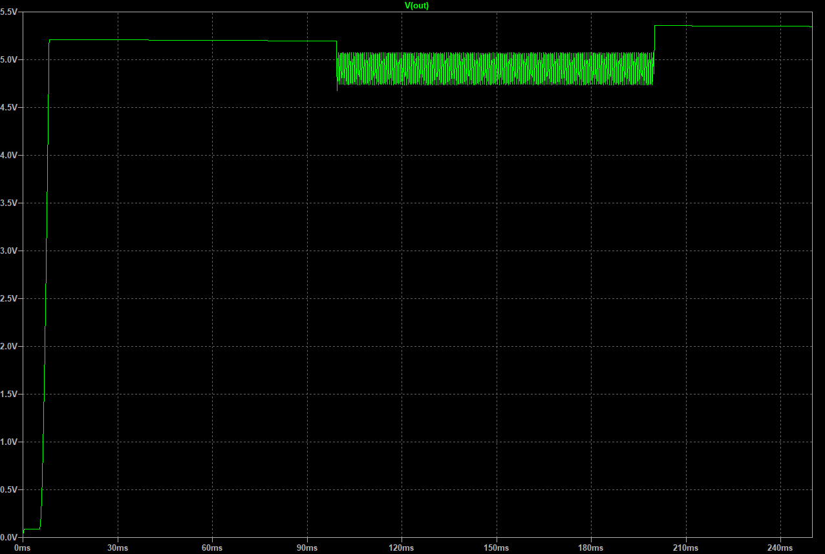

30V Input, 25V 1A Output

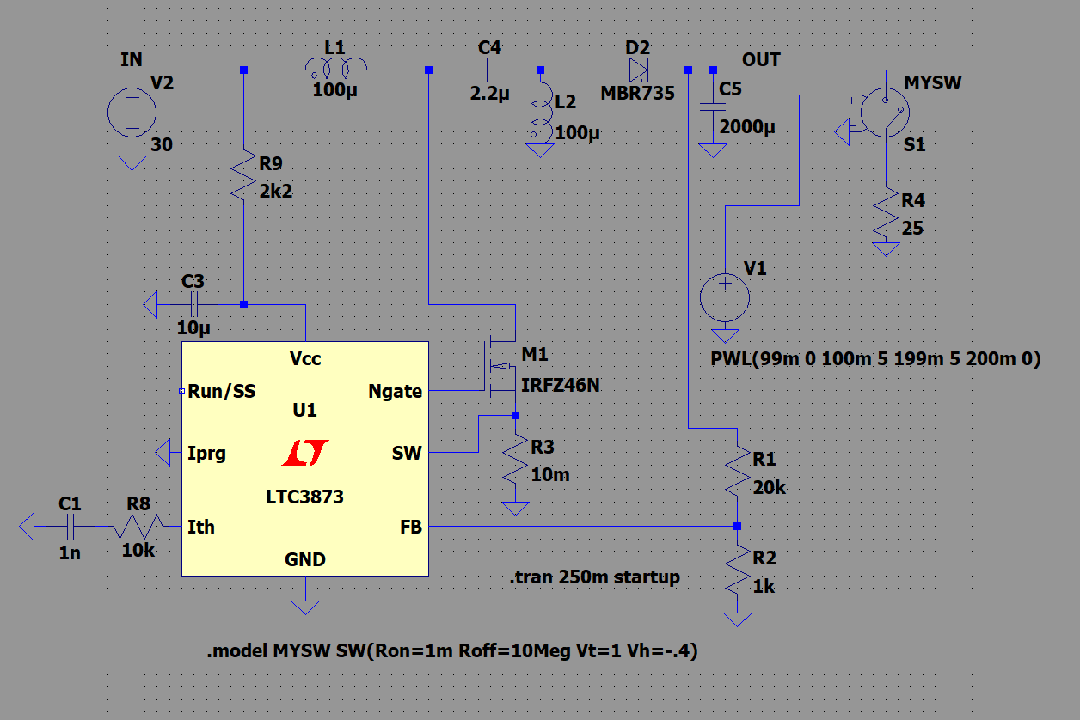

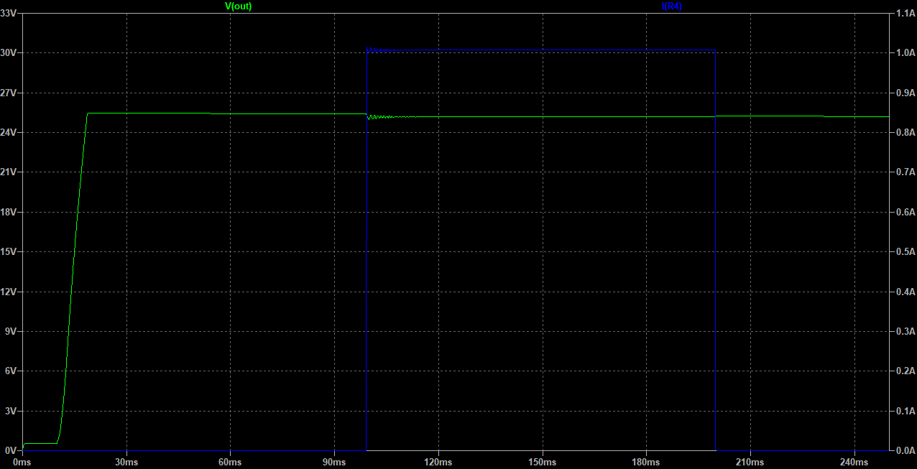

30V Input, 15V 1.6A Output

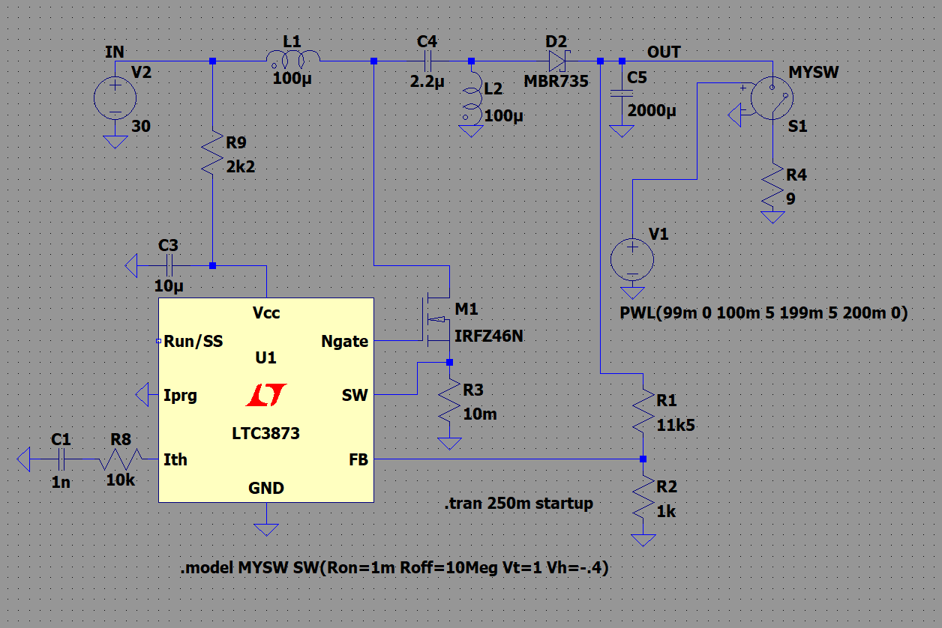

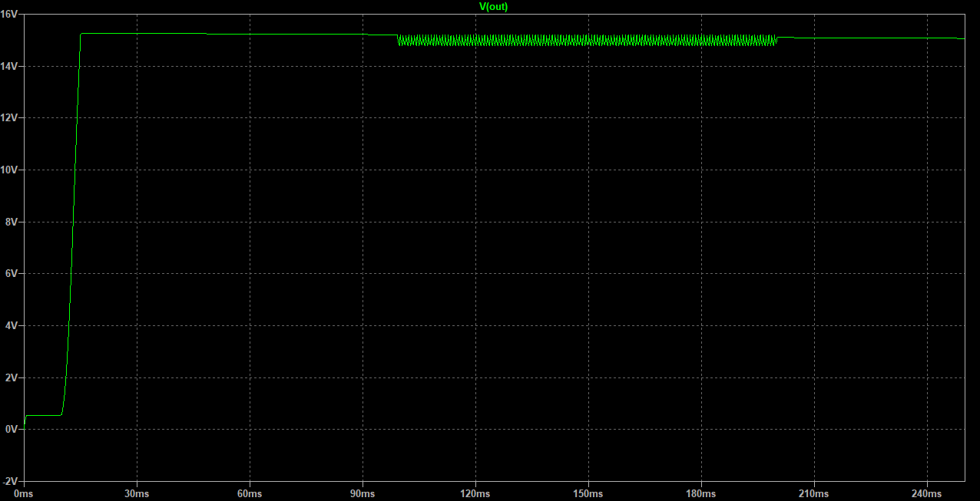

30V Input, 5V 5A Output

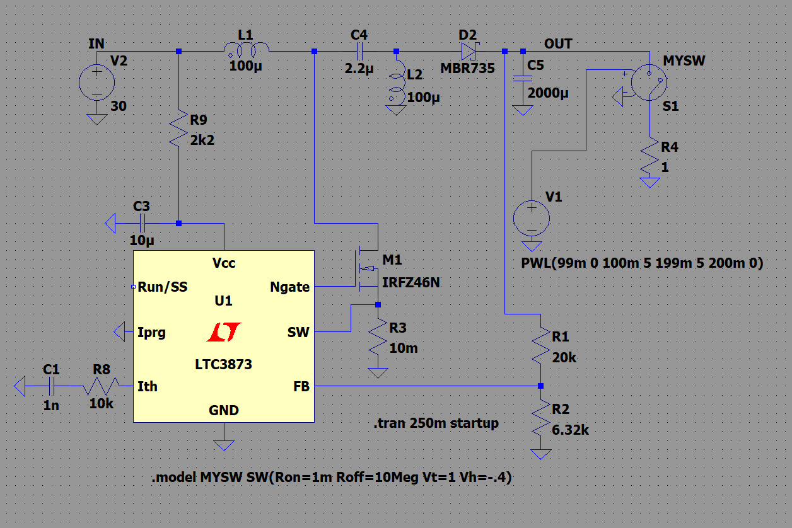

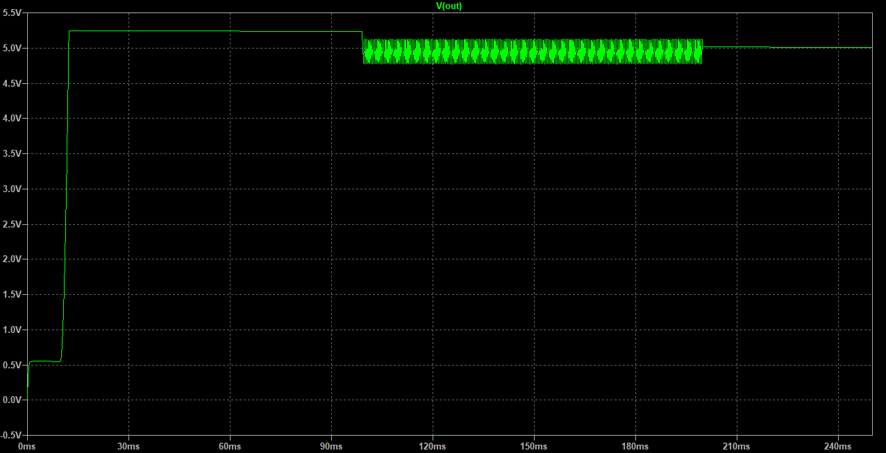

So, as we can see not all voltages and power demands are satisfied. Note that I didn’t tweak power stage, just dropped minimum required calculated values for average input(27V) and output(15V 1.6A) value. Also, compensator values are try and error. Now, we are going to try designing 9-20V input, 5V 5A output design. And, examine result and try again, until get proper regulation at 5A and for sudden power demand changes(We tested with simple switch to connect and disconnect load at 100ms and 200ms like we did in previous examples.).

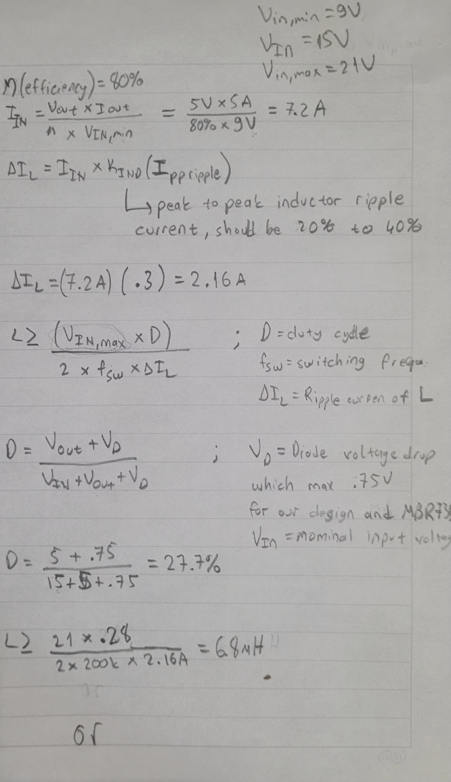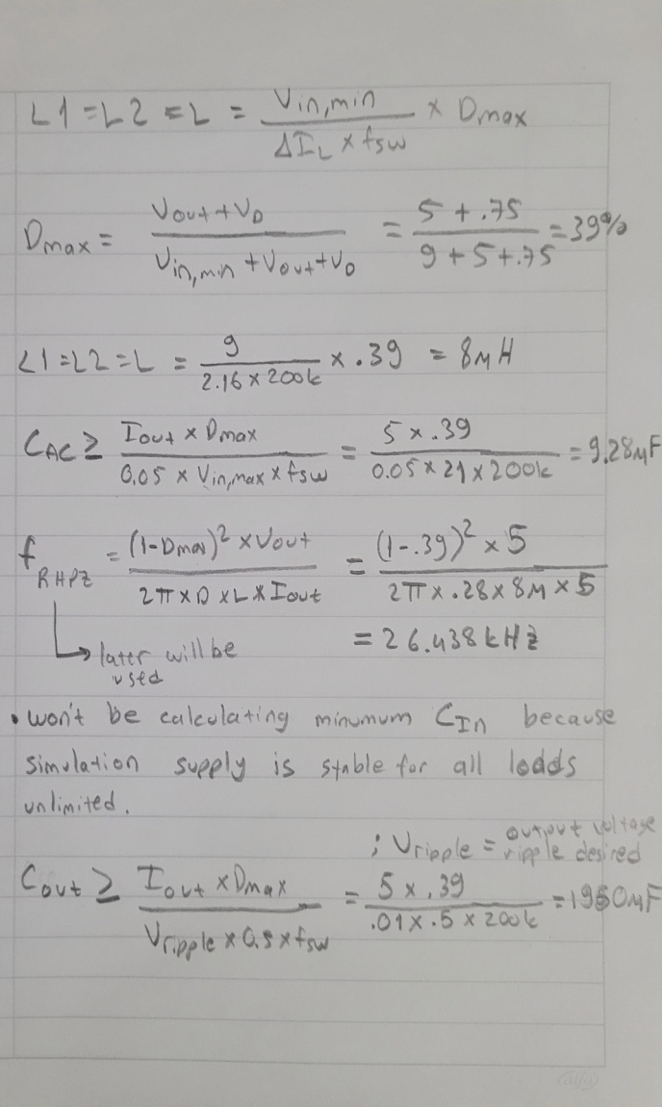

Iin 🡪 input current which sunk from input supply in our case and in simulation from 9V voltage source(V2).

Delta IL🡪 Inductor ripple current

KIND🡪 Ratio of input current to inductor ripple current

“A good rule for determining the inductance is to allow the peak-to-peak ripple current to be approximately 40% of the maximum input current at the minimum input voltage. “ **From AN-1484 page 3**

L🡪 inductor

CAC🡪 Coupling Capacitor

This are the power stage calculation which shouldn’t be forgottten will probably not be enough values in real life(L and C values may need to be higher). But, it is good starting point. Secondly we will do more suitable simulation with compensation calculation. Why is different in real life? Components aren’t ideal in real life. Inductors will have leakege currents, capacitors have equilevent series resistant(ESR) … Let us apply this power stage inductor and capacitor values to remaning 9V in, 5V 5A out simulation and see difference.

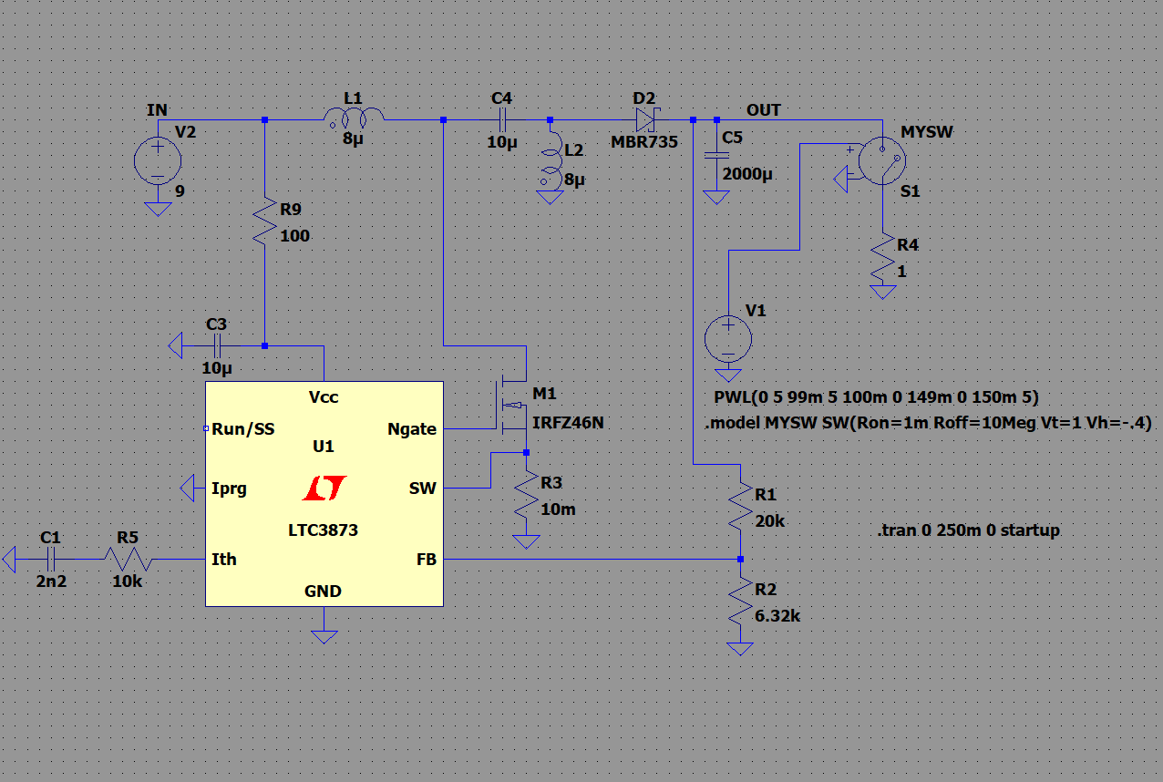

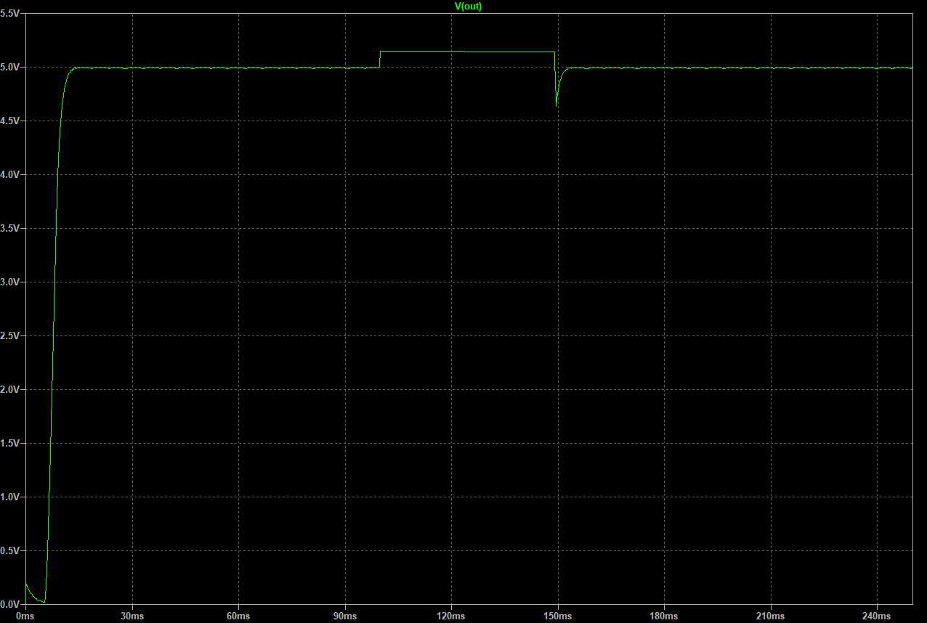

As we can see regulation and response of supply is bad for now, but can supply required current for the load. Because we recalculated power stage for new Vin range, Vout and Iout.

So how it works?

<https://www.youtube.com/watch?v=XOcA7ijtlCY>

also you can check first three page of SNVA168E for related graphs.

SEPIC converter transmit power through power stage. Uses inductance properties to do it efficiently. Drives current through indcutors to convert energy to output as needed. Inductors basicly show complex resistance to current changes. When circuit apply constant input voltaj to inductors. Inductors begin to be load of current which rises consistently. Which we calculated Delta IL. Which was 2.16 A. In simulation this is close to calculation.

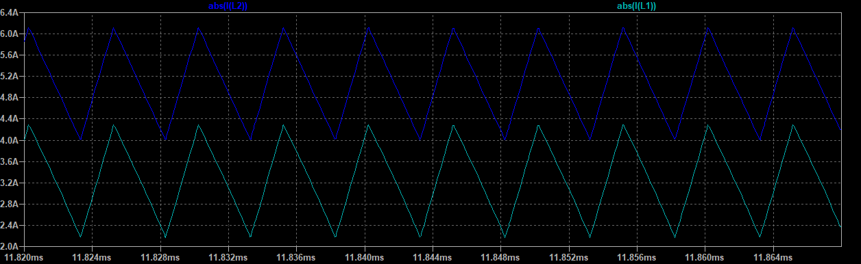

As you can see current on the inductor changes because of the inductor properties when current rising energy pumped to the inductor. But in real life inductor like a transformer will go to saturation. Which will be related to current and frequency properties of inductor. So at that point current will be flat so inducter becomes a resistor so wastes energy like a resistor. Because, in that situation current on inductor is constant. In real life, you will see this more like a sinus wave because every time step inductor goes saturation. But, it is normal unless you see top of signal is flat. On that point you need operate in higher frequncy so you will pump current to inductor shorter times so it won’t go to saturation or more capable inductor.

Inductors need more attention because they are key compenent to transmit power.

Kind value there is to desice some properties of the converter, some trades.

Choosing a higher KIND leads to:

• Lower recommended inductance

• Higher current ripple

• Higher EMI

• Faster transient performance

• Larger output capacitance for a desired output ripple

Page 3 of SNVAA43

So you choose a Kind value so calculated delta IL changes things.

Now capacitors, they show resistance to voltage change. Don’t need more explaining there I guess which will be beneficial for you but some other value of capacitors. Which I mentioned is ESR. This value is important for efficiency and compenstaion. You will see when calculating compensator. Also, ESR in the name series equilevent resistance will be a power loss and affect pumped value to output because output capacitor is a energy storage when switch closed/inductors pumped which will act and another paralel load. When energy/current pumped to capacitor or output will be another power loss because the P=(I^2)*R. So lower ESR caps considered quality and better. But, electroliquid capacitors with high ESR is still used because firstly cheap, secondly high ESR allows to design and controlling power supply with Type II compensator which is easier to implement. You can see relation

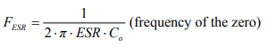

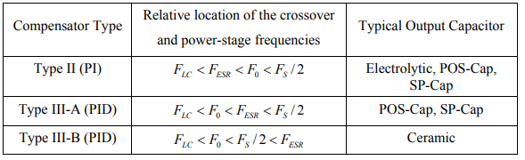

From Application Note AN-1162

That I mentioned switch mode supplies design for a range of input and one desired output most of the time. Sometimes it is hard to design for multiple outputs. But for every different input,output needs you can calculate all power stage and compensator values quickly and you can change the same board and you are ready to go. Commercial variable power switch supply products/modules you can find on the internet, usally fixed compensators in the IC(which is probably well design with accuracy because compensator values mostly change with power stage, other fixed values which affects compensation calculations in the IC that won’t affect beacuse they are fixed) and good for with power stage calculation for specific output. But, this doesn’t means a 100W supply will be good for all 1W outputs.) And all of calculation is for CCM, LTC3873 has no feature for DCM and light loads efficiency I can see in the datasheet. And, i will not be explaning DCM because I have little knowledge and need more complex design(this doens’t concern you beacuse feature integrated in ICs but mentioned) and highest quality of inductors. Needs high quality inductors I read about because in DCM you won’t be always pumping and pulling energy from inductors.

Now, we can move on to compensator design. SEPIC converter are the most difficult DC/DC non-isolated converter to design compensator for that I read. Because has more poles. But, good compensation can be achived with a type II compensator which is easier to design. It will be too long to explain compensator with writing. But, I’ll give video links those explain compensator. If you have more question, you can always ask to me via Discord with chat or verbally call. Also, all sources will be provided that I took calculation equations from.

<https://www.youtube.com/watch?v=clUtlYPEwfc> 🡪 beginning and ending of mostly

<https://www.youtube.com/watch?v=PkjDUQjEDBw> 🡪 you can look this for general compensation knowledge and what is a compensator

<https://www.youtube.com/watch?v=abelKfvEtgE>

<https://www.youtube.com/watch?v=ESz64YnDEIg>

<https://www.youtube.com/watch?v=l0bELIic8PE>

I’ll try to explain in few sentences but you should know that it is a very deep topic. Also, you don’t need to overthink about it because with provided equations you can calculate easily to some degree that you will be fine most of the time. In the first video mentioned some of it. Compensator controls switching element of converter to supply fixed output voltage by cheking output voltage with different methods. Basicly, we try to change gains at some points(which are poles) according to model so switched mode supply can provide well steady-state output and fast transient response to load changes. You can ask about the things you are curious about to me. I can explain to you as much as I know.

Below part is from an application note about designing comensators you will be provided.

“The purpose of adding compensation to the error amplifier is to counteract some of the gains and phases contained in the control-to-output transfer function that could jeopardize the stability of the power supply. Obviously, the ultimate goal is to make the overall closed-loop-transfer function (control-to-output cascaded with the error amplifier) satisfy the stability criteria. This is to avoid having the closed-loop phase any closer to 360 degrees than the desired phase margin anywhere the gain is greater than 1 (0 dB). It is also desirable to have the slope of the gain curve at the crossover point with a value of –20 dB/decade. Phase margins of 45 degrees to 60 degrees (360 degrees minus the total closed-loop phase lag) are considered safe values that yield well-damped transient load response.”

The purpose is basically phase boost on poles and cut-off frequency so gain will be high on those point which will be resulted by good response and not go to positive feedback.

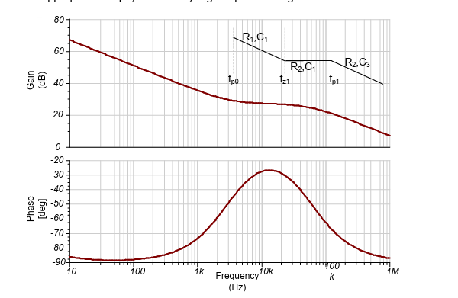

SLVA662 Application Report

You can read more about compensation in

AN-1990CompensationforCurrentModeControlSEPIC Converters **SNVA405A**

AN-1286 Compensation for the LM3478 Boost Controller **SNVA067D**

AN-1484DesigningASEPICConverter **SNVA168E**

Demystifying Type II and Type III Compensators Using Op Amp and OTA for DC/DC Converters **SLVA662**

Now we are going to do compensator calculation. You don’t need to fully understand but as long as you follow the calculations you will be fine. And, like all of the calculation this will be a starting point too. Because in the datasheets you will see,

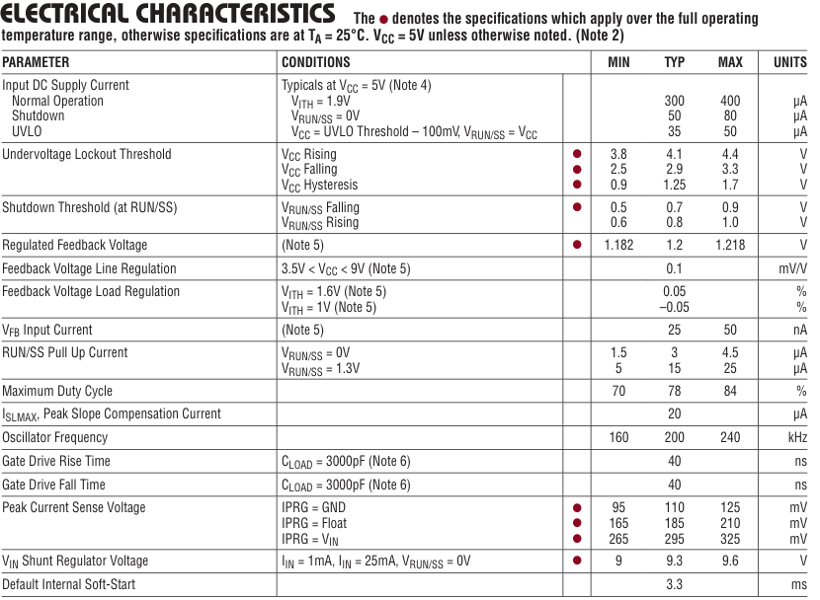

values are not guaranteed. So, you may need to tweak again. First of all to calculate compensator passive components we need some values. All will be driven by known values. But, to calculate we need transconductance value of operationa transconductance amplifier in LTC3873. This value is provided if compensation needed to be decided with complementary parts. In this case it is not. So, we will use model of LTC3873 in simulation to get this value.

Basically, OTAs is similar to opamps but opamps are voltage input-voltage output devices. OTAs are voltage input-current output devices. Transconductance value of OTA defines how much output current will be according to voltage difference of input terminals. In LTC3873 positive terminal of OTA is connected to voltage reference which is 1.2V. This reference voltage also indicates lowest ouput voltage can be supplied with controller.

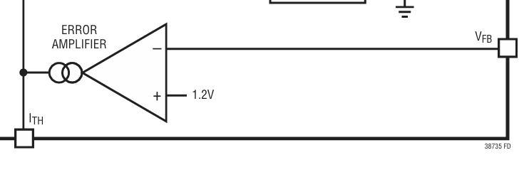

So, we are going to apply 100mV peak to peak sinusoidal signal with offset of 1.2V. Then we will see per voltage difference on inputs 🡪 output current. Again, this is provided in datasheet normally. But first you need to see that OTA outputs current. I will show that with changing resistor on Ith pin so you can see current will not change but, voltage will change according to resistor and ouput current of OTA.

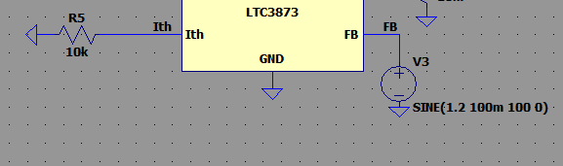

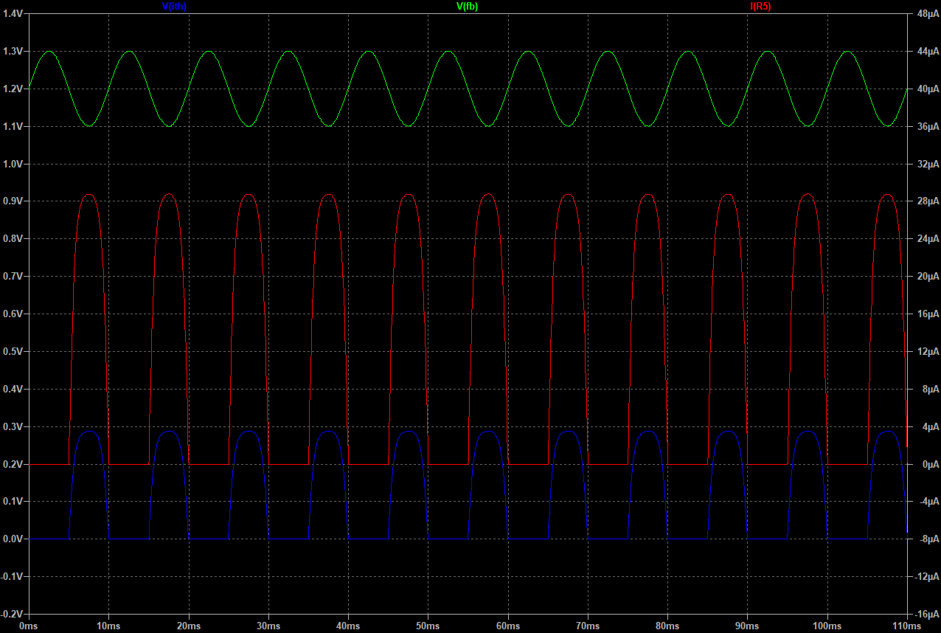

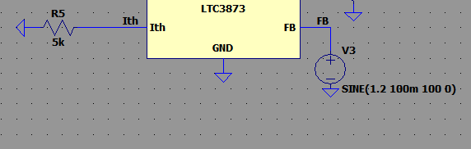

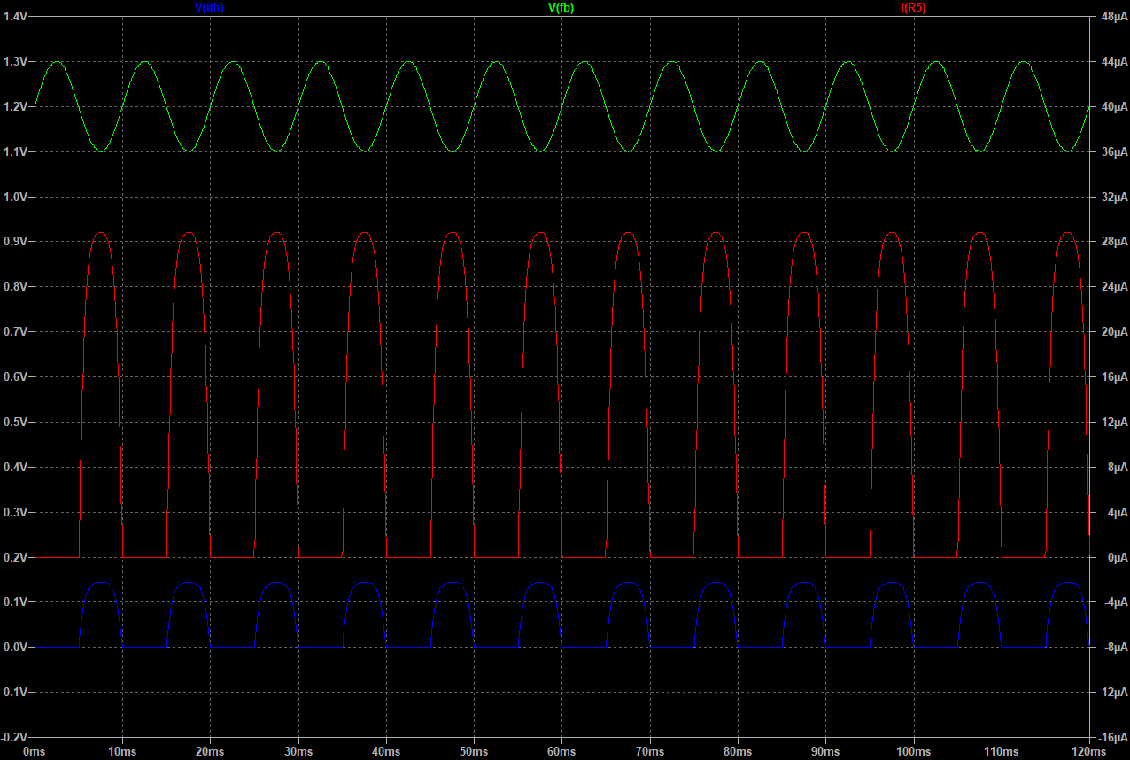

Now, transconductance value which represented with Gm or gm. Will be unit of A/V. So, we will add a plot which will be , equal to Ith/(Vfb-1.2V).

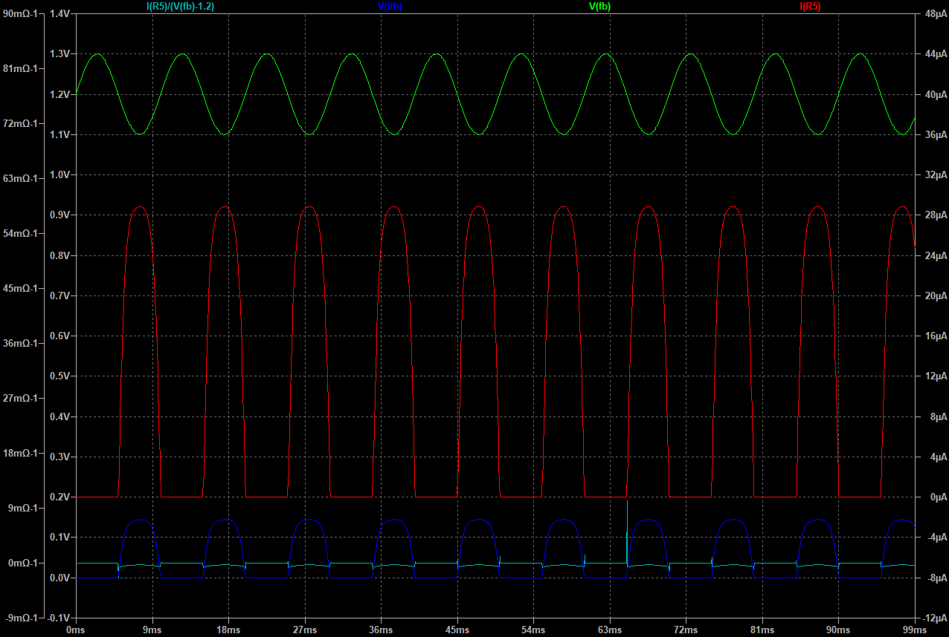

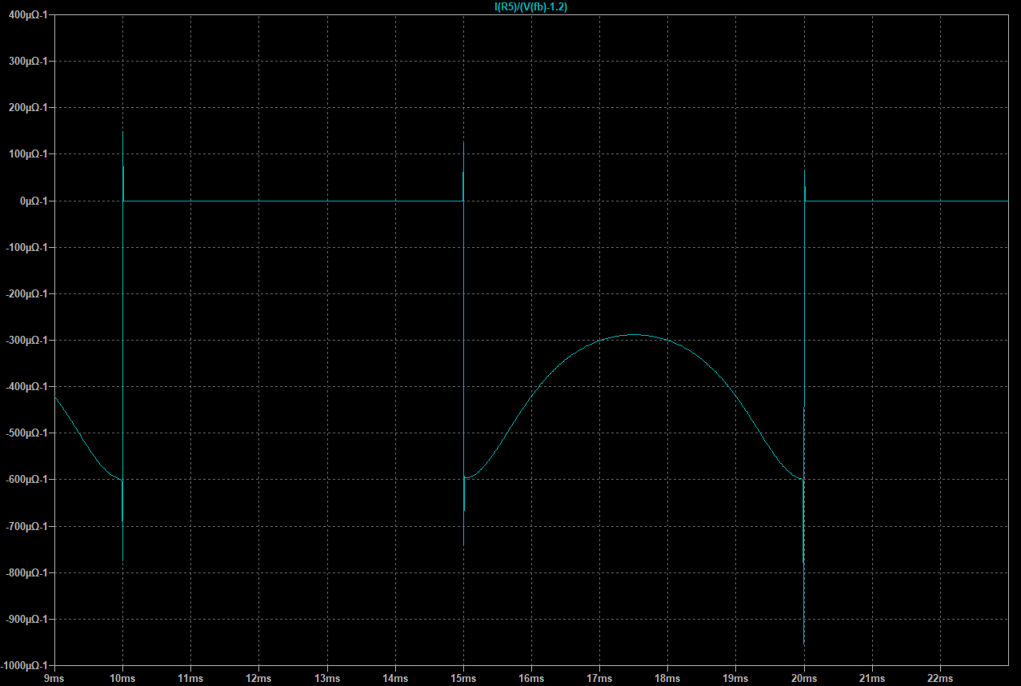

It is not linear but it impossible I guess because all datasheets gives values under condition so they can give data. This is not just for this for Gm, it is always like that but as an example below pics from OPA860 datasheet which is an OTA.

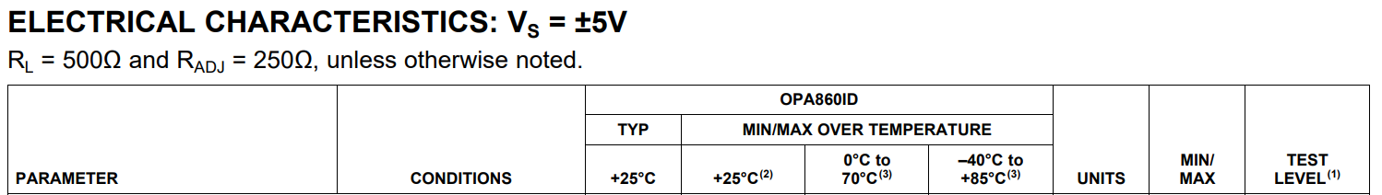



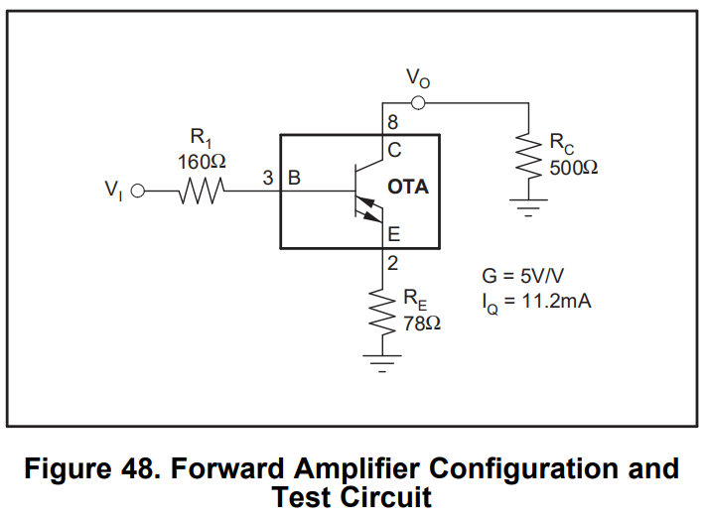

As you can see they give the result for ideal conditions Rc and Re equal to zero. To be safe side, I give 1V amplitude to the sinusodial wave.

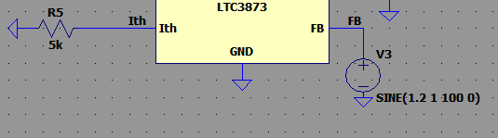

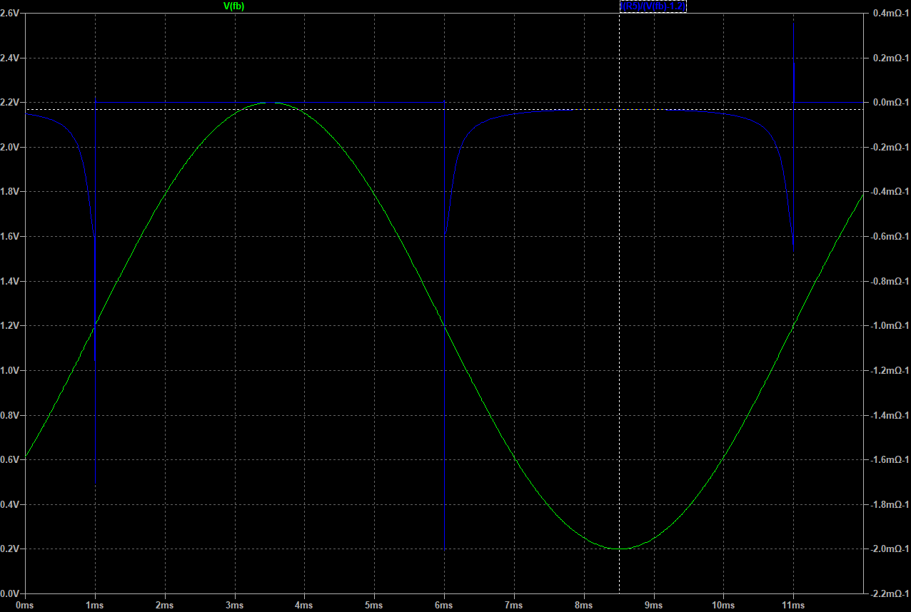

Values is seemingly going to limit of 30u ohm en max 600u ohm. I’ll take a point around rising edge. Because it’s not ideal to FB pin to swing with 100mV. If Vfb would be 100mV minus or plus of reference voltage 1.2V it will mean output voltage will swing nearly ½ V and it’s not desirable. So, at the end output will not swing that much so Vfb.

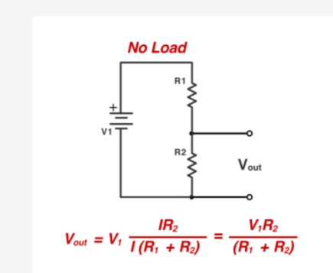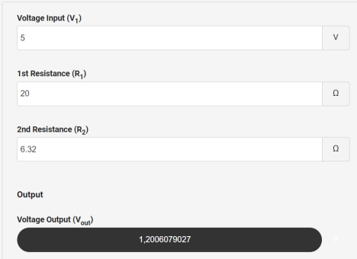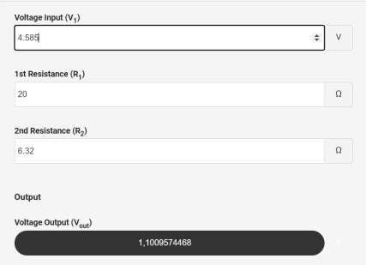

So I’ll take Gm = 550 Ω-1 or 550A/V. According to maxmimum swing we want which 2%. For 5V it is 100mV. 100mV output decrease 🡪 Vfb=1.176V. At that point Gm is 550 Ω-1.

Next we need R0 output impedance but simulation result of AC analysis results 0 with no load attached to Ith pin. It isn’t correct. So I’ll do my calculation according to this. In datasheet,

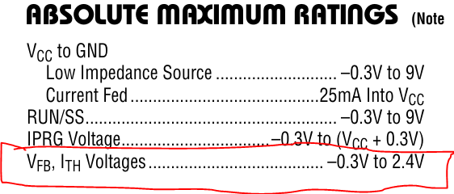

I tried with up to 2 megaohm resistor and 20V sinus wave to see absolute max OTA can give.

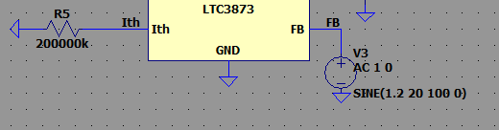

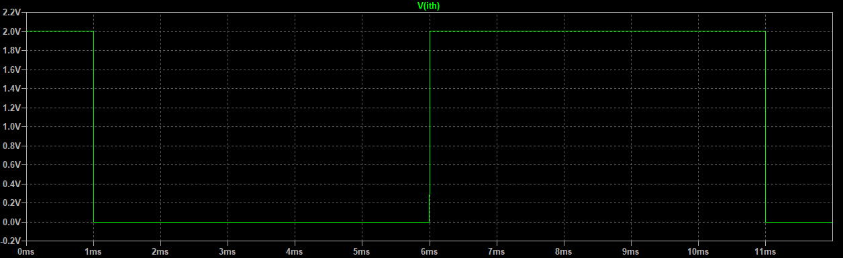

It is 2V. And max current is 30uA. So Rout = V/I = 2/30u = 66.666k. It’s not right but it is what we can do. Normally you do the same in real life feed a sinusodial wave but shorting Ith pin and V/I ….

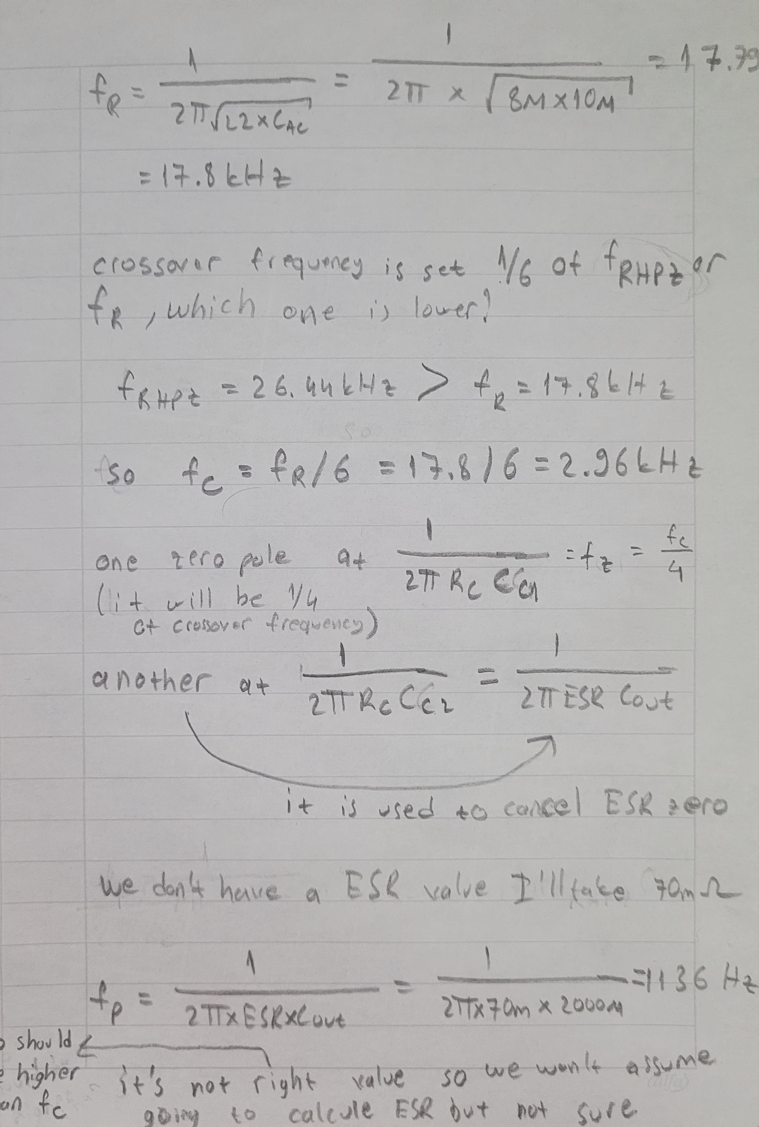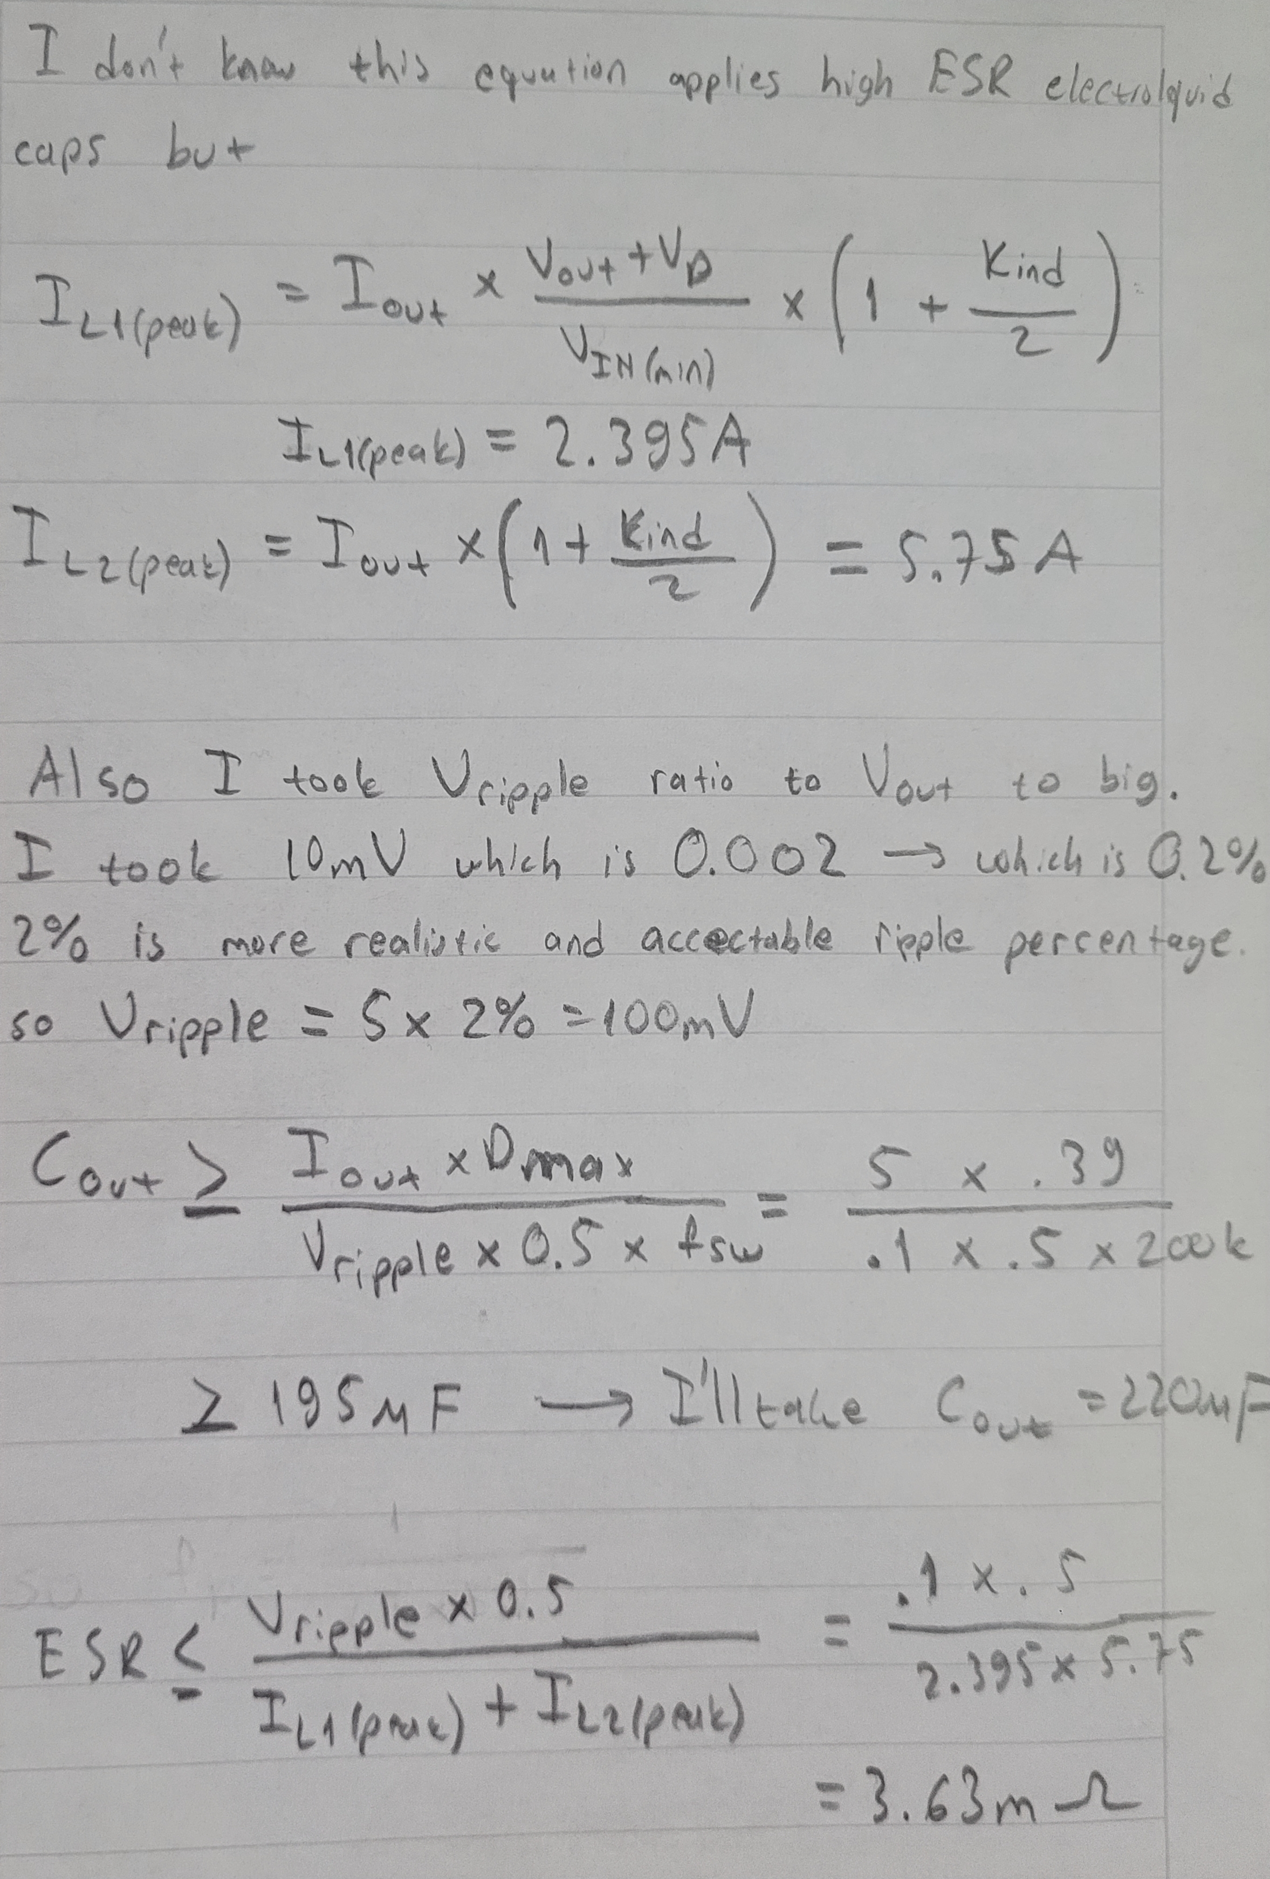

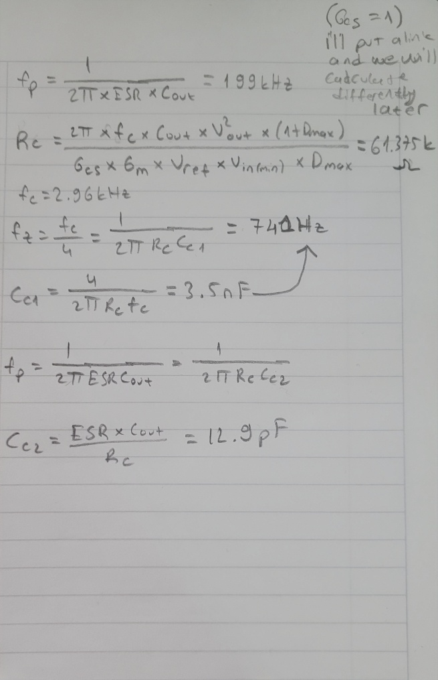

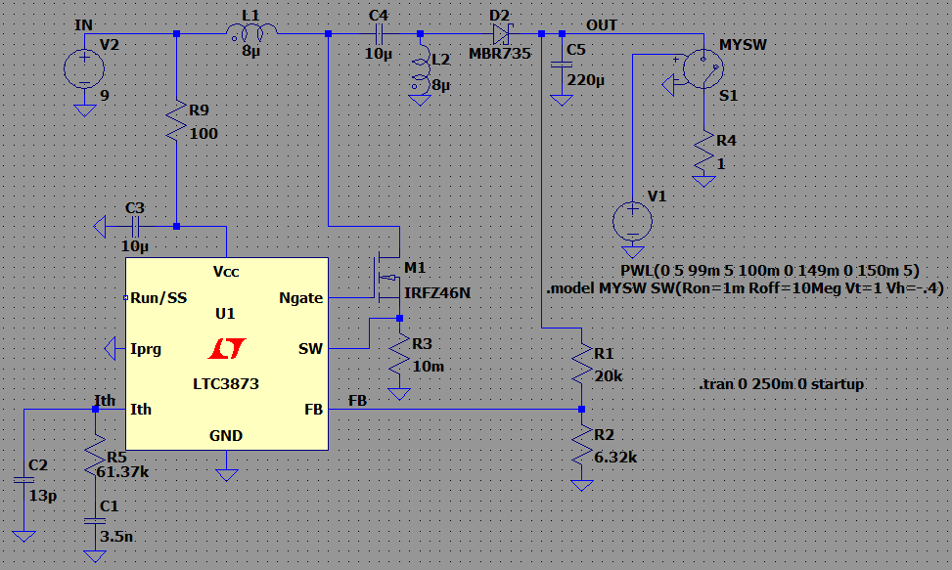

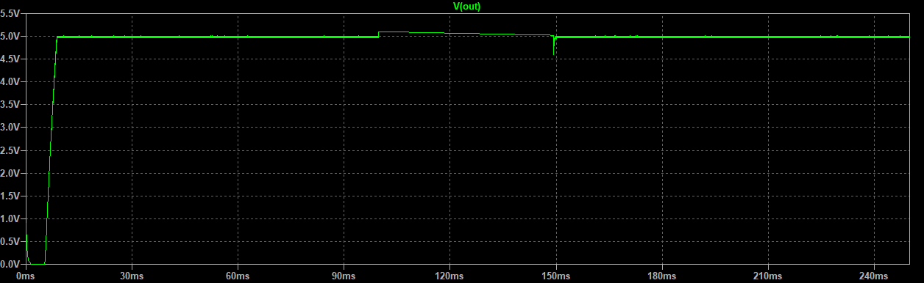

But im not satisfied because it’s not clear for you and also i missed a one or 2 steps but at the end i will mention those to. Link about Gcs is this : <https://e2e.ti.com/support/power-management-group/power-management/f/power-management-forum/1036408/lm3478-current-sense-gain>

I will edit application note we will continue on that and I will make another file for you to continue. It will be 4 files current mode 🡪 cm, voltage mode 🡪 vm and edited pdf for cm

So steps for you to read it like this;

cm1 🡪 edited pdf 🡪 cm2 🡪 voltage mode

but first lets check if the compensator network satisfies calculations.

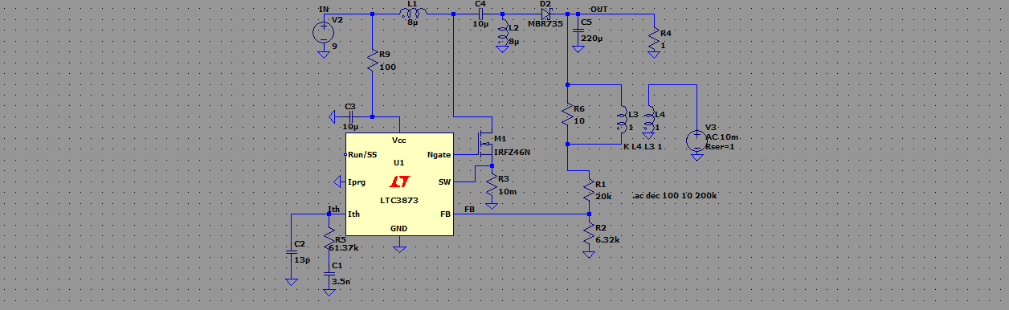

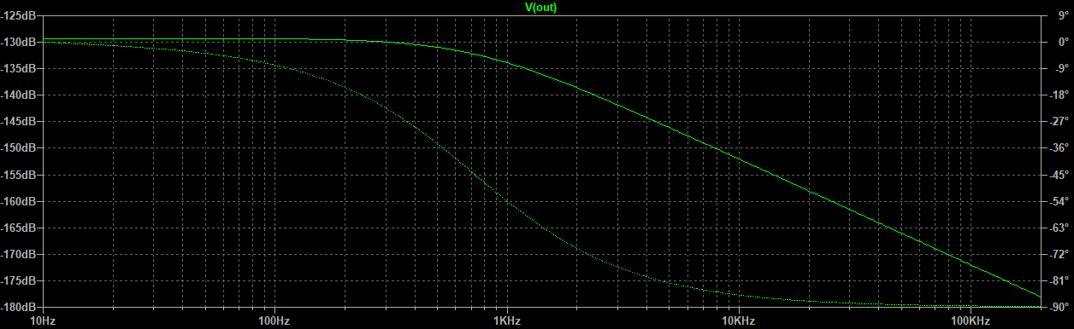

Not good at all because not wanted values I’ll explain in cm2 document more of it. Last one is wrong I did explained in cm2 AC analysis doesn’t work.